Assignment no. 11
Code:
import tensorflow as tf
from tensorflow.keras.datasets import mnist
from tensorflow.keras.models import Sequential
from tensorflow.keras.layers import Dense, Flatten
from tensorflow.keras.utils import to_categorical
# Load data
(x_train, y_train), (x_test, y_test) = mnist.load_data()
# Normalize and one-hot encode
x_train, x_test = x_train / 255.0, x_test / 255.0
y_train_cat = to_categorical(y_train, 10)
y_test_cat = to_categorical(y_test, 10)
# Build model
model = Sequential([
Flatten(input_shape=(28, 28)),
Dense(128, activation='relu'),
Dense(10, activation='softmax')
])
# Compile model
model.compile(optimizer='adam', loss='categorical_crossentropy', metrics=['accuracy'])
# Train
model.fit(x_train, y_train_cat, epochs=5, validation_data=(x_test, y_test_cat))
# Evaluate
loss, accuracy = model.evaluate(x_test, y_test_cat)
print(f"Test Accuracy: {accuracy:.4f}")

Output:
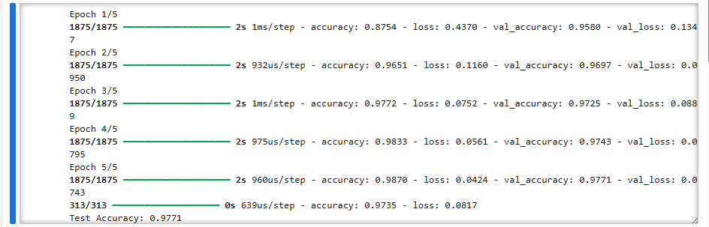

Code:
import tensorflow as tf
from tensorflow.keras.datasets import mnist
from tensorflow.keras.models import Sequential
from tensorflow.keras.layers import Dense, Flatten
from tensorflow.keras.utils import to_categorical
# Load data
(x_train, y_train), (x_test, y_test) = mnist.load_data()
# Normalize and one-hot encode
x_train, x_test = x_train / 255.0, x_test / 255.0
y_train_cat = to_categorical(y_train, 10)
y_test_cat = to_categorical(y_test, 10)

# Logistic Regression Model (no hidden layers)
model = Sequential([
Flatten(input_shape=(28, 28)),
Dense(10, activation='softmax')
])
# Compile and train
model.compile(optimizer='sgd', loss='categorical_crossentropy', metrics=['accuracy'])
model.fit(x_train, y_train_cat, epochs=10, validation_data=(x_test, y_test_cat))
# Evaluation
loss, accuracy = model.evaluate(x_test, y_test_cat)
print(f"Logistic Regression Accuracy: {accuracy:.4f}")

Output:
